
August 29, 2013

Re: KY – Overlay Relief Plan New Area Code (364) to overlay Area Codes (270)
2nd Notification

Dear Customer,

On December 17, 2012, the Kentucky Public Service Commission (KY PSC) in Case No. 2012-
00129 ordered an all services overlay with the implementation dates shown below as the relief
method for the 270 NPA. The 270 NPA generally covers the western half of Kentucky serving
communities such as Bowling Green, Elizabethtown, Henderson, Hopkinsville, Owensboro and
Paducah. The new 364 NPA will serve the same geographic area currently served by the
existing 270 NPA. A map showing the area served by these NPAs is attached.

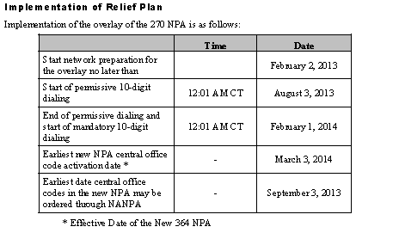
During the permissive dialing period, subscribers may dial local calls within the overlay area on
either a 7-digit or 10-digit basis, but will be encouraged to dial 10-digits. After the permissive
period ends, all calls must be dialed using 10-digits.
When preparing for overlay area code relief, carriers are strongly encouraged to prepare their
switches to begin sending 10 digits prior to the mandatory 10-digit dialing conversion date for
customers.
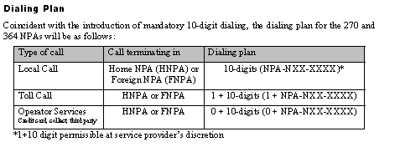
Network Testing
All international and domestic carriers should ensure that the new 364 NPA has been activated
throughout their networks prior to March 3, 2014. The test number to verify the routing to the
new NPA will be in service beginning December 2, 2013 through April 3, 2014. The test number
to verify the routing to the 364 NPA is 364-364-1364. A recorded announcement will indicate
that the test call has been successfully completed.

